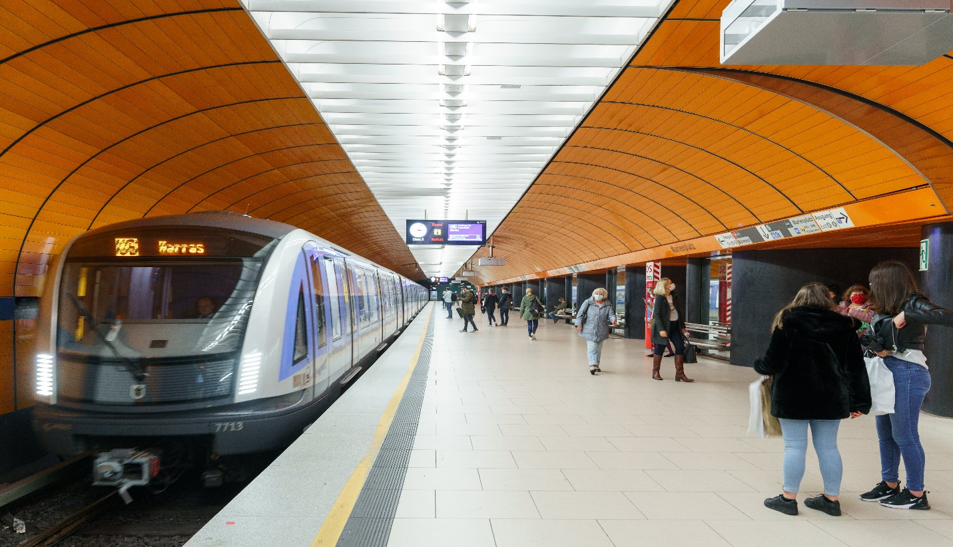

**Channel Tunnel**

The Channel Tunnel is a rail tunnel beneath the English Channel, connecting Folkestone in the United Kingdom to Coquelles near Calais in France.

**History**

The Channel Tunnel, completed in 1994, connects England and France, serving as a rail and vehicle transportation link beneath the English Channel.